**Annex G: Testing the Filled and Sealed Pratt Pouch**

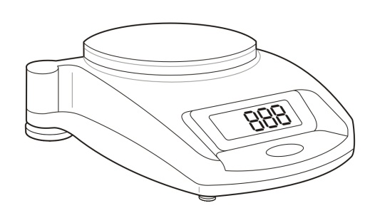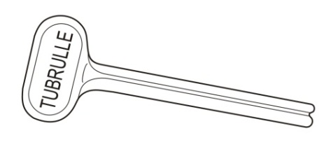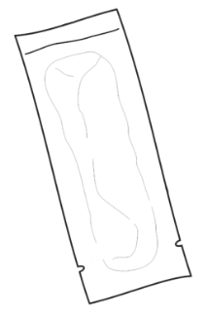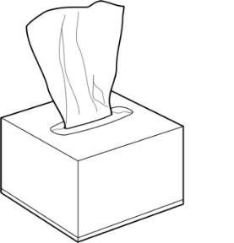**[](https://portal.intrahealth.org/Departments/Communications/Image%20Library/IntraHealth%20logo/IntraHealth%20Logo%20for%20Documents%20in%20Word%20and%20PPT.jpg)**

**2.1 Weigh one empty pouch and record it weight on the Training Data Collection Spreadsheet: *“Weight of Empty Pouch”***

* Approximate acceptable weight range = 0.7g

**2.2 Fill the pouch with 2.2 ml of either NVP or water**

**2.3 Weigh the filled pouch and record its weight: *“Weight of Filled Pouch”***

Handle

Slot

**Tissue Box**

**Scale**

**Filled/sealed  
Pratt Pouch**

**Squeeze device**

Bottom edge

Seal

Tearing notches

**Part 2: Pouch Weight Test**

**Part 1**: Assemble all Supplies

**2.4 Calculate the weight of contents in a filled pouch:**

**Weight of Contents = Weight of Filled Pouch-Weight of Empty Pouch**

.

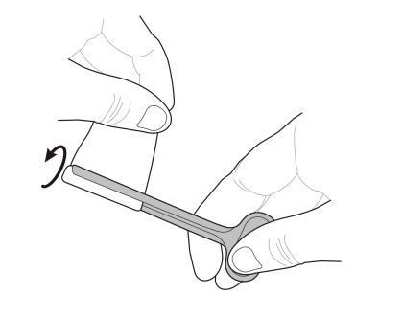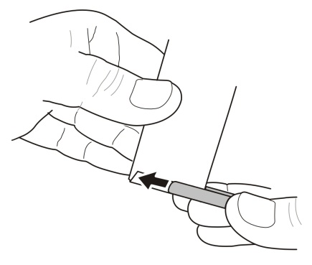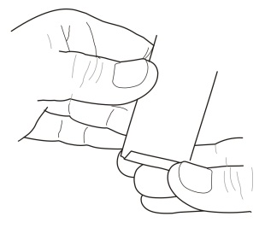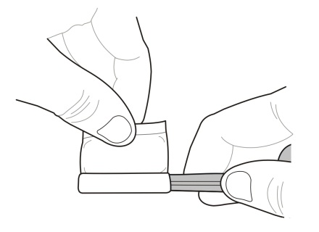

Figure 4

Figure 3

Figure 2

Figure 1

**3.4 Very firmly** hold the device/pouch in the fully-compressed position for   
5 seconds (**Figure 4**)

**3.5** If any of the pouch **contents become visible** during Step 2.4, the seal has been broken and the pouch has failed.

**3.6** If the pouch **seal remains dry** during Step 2.4, the pouch was sealed   
correctly and has passed the burst test.

.

**3.3 Holding** the pouch tightly in place against the squeeze device, slowly rotate the device until the pouch contents are fully compressed into the top of the pouch (**Figure 3**).

**3.2 Slide** the folded area of the pouch (double thickness) into the slot   
of the squeeze device (**Figure 2**).

**2.5** Determine if weight of contents are within acceptable weight ranges:

* **Approximate weight of contents in a pouch with 2.2 ml Water = 2.200g**
  + **Approximate acceptable weight range for 2.2 ml Water = XXXXX**
* **Approximate weight of contents in a pouch with 2.2 ml NVP = 2.332g**
  + **Approximate acceptable weight range for 2.2 ml NVP = XXXXX**

**3.1 Fold over** the bottom edge of the pouch at the tearing notches as shown (**Figure 1**). Crease fold so pouch stays folded.

**Part 3: Pouch Burst Test**